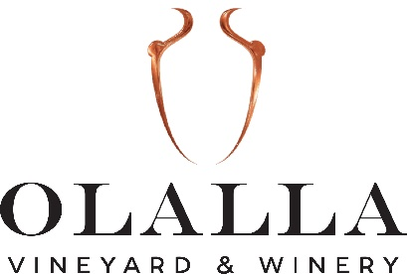

FAQ

Q. What are your business hours and when do you offer tastings?
A. WE HAVE LIMITED TASTING ROOM HOURS DUE TO A FAMILY EMERGENCY. THANK YOU FOR YOUR UNDERSTANDING AT THIS TIME.
Our tasting room is open Friday, Saturday and Sunday and closed Monday thru Thursday.
Friday and Saturday Open from 12-6pm – tastings are from 12-5:30pm
Sunday Open from 1-5pm – tastings are from 1-4:30pm

Q. How much are tastings and what do they consist of?
A. Tastings are $10/person plus 9% WA State Sales Tax. Tastings consist of five (5) one-ounce pours (the equivalent of one glass of wine) of five different wines. Typically, our tastings consist of two white wines and three red wines. One tasting fee is waived with the purchase of two bottles of wine.

Q. Are children and dogs allowed at the winery?
A. Well-behaved children under CLOSE adult supervision are always welcome during tasting room hours. Well-behaved pets that are on leash are welcome onto the winery grounds during tasting room hours. Please pickup after your pet. Please, no pets indoors. Friday evening live music events are 21+ and no pets allowed.

Q. Where can I purchase a ticket for an event?
A. Tickets can be purchased on our webpage under the “SHOP” tab at the top of our main page.

Q. Do you offer gift cards?
A. Yes, we offer gift cards in any denomination. Gift cards can be purchased in our tasting room or online under the menu tab “SHOP” on our main page.

Q. Do you offer private events?
A. Yes, please email us at events@olallawines.com for more information. We are a wedding venue and private event venue. Our outdoor capacity is 100 guests and our indoor capacity is 35 guests.

Q. Do you have restroom facilities available?
A. Yes, we have a restroom in our tasting room.

Q. Are you ADA accessible?
A. Yes, most amenities are available to those who require ADA access. Tastings can be done in the front patio area which is level with the parking lot. During summer hours, we have an ADA bathroom facility right near the parking lot. Friday Night concerts are held in the back vineyard and the concert venue is ADA accessible.

Q. I have never been to a Friday Night concert event at the vineyard. What can I expect?
A. Expect to have a fun time! Also, here is some very important information:
1. Absolutely no outside alcohol is allowed on our premises.
2. You can bring your own picnic-style foods for consumption at the concert if you are seated in the vineyard only. Please, no pizza boxes or fast food items.
3. Please bring a lawn or camp chair to sit on in the vineyard.
4. Wine is sold by the glass and by the bottle during the concert.
5. We have picnic baskets available for purchase. Here is our menu:

Veggicopia Olives $2.00
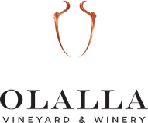
Picnic Baskets

“crimson cove” smoked cheese and crackers picnic basket $12.99
Sharp Cheddar, Swiss, Pepper Jack or Gouda cheeses (choose two)
La Panzanella Crackers (Original or Rosemary) *

“CRIMSON COVE” SMOKED SALMON SPREAD $15.99
La Panzanella Crackers - Choice of Original or Rosemary

“CRIMSON COVE” SMOKED cheese AND SALAMI picnic basket $17.99
Salami with choice of
Sharp Cheddar, Swiss, Pepper Jack or Gouda cheeses (choose two)
La Panzanella Crackers (Original or Rosemary) *

“crimson cove” smoked salmon and cheese picnic basket $17.99
Traditional or Mild Cajun Smoked Salmon with choice of
Sharp Cheddar, Swiss, Pepper Jack or Gouda cheeses (choose two)
La Panzanella Crackers (Original or Rosemary) *

Snacks
Hummus Dip and Stacy’s Pita Chips $3.50
Veggicopia Olives $2.00

“Gig Harbor Candy Company’s” Chocolates

“GIG HARBOR CANDY COMPANY” CHOCOLATES
MILK or DARK CHOCOLATE SEA SALT CARAMELS - $13.99 (9 oz. box)
“CRIMSON COVE” SMOKED NUTS $7.99/bag
Choice of Cashews or Mixed Savory Nuts
*GLUTEN-FREE OPTION AVAILABLE UPON REQUEST

WA STATE SALES TAX OF 9.0% WILL BE ADDED TO ALL SALES

